Report for Homework 1

COP 4610

Jose Toledo and Jasmine Batten

# Screenshot #1: Version (uname -a)

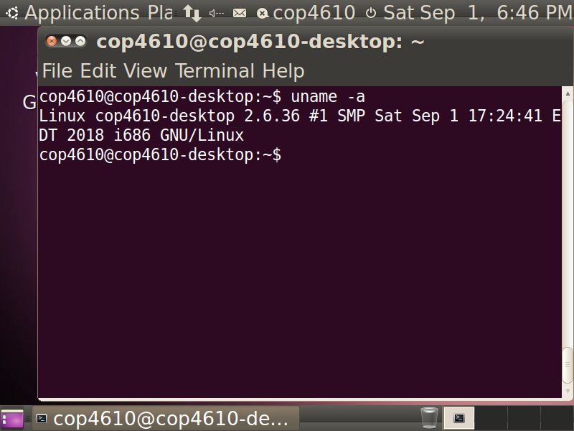

# Screenshot #2: Module testing (lsmod)

# Screenshot #3: Module testing (dmesg|tail)

# Screenshot #4: Removing module (dmesg|tail)

# Screenshot #5: Removing module (lsmod)

# Screenshot #6: System call testing (dmesg|tail)

